## System Usability Scale

© Digital Equipment Corporation, 1986.

Strongly Strongly

disagree agree

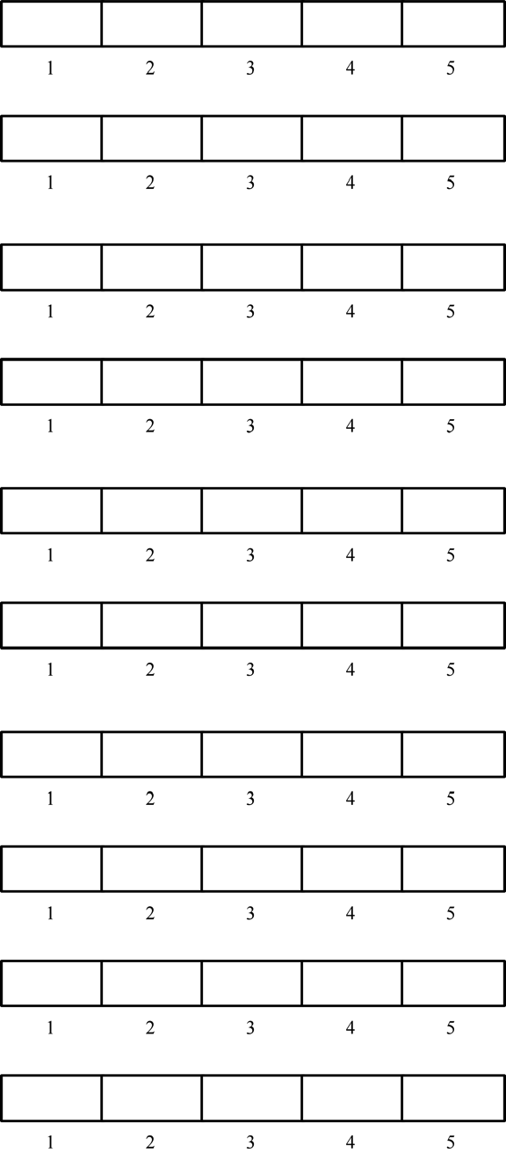

1. I think that I would like to

use this system frequently

2. I found the system unnecessarily

complex

3. I thought the system was easy

to use

4. I think that I would need the

support of a technical person to

be able to use this system

5. I found the various functions in

this system were well integrated

6. I thought there was too much

inconsistency in this system

7. I would imagine that most people

would learn to use this system

very quickly

8. I found the system very

cumbersome to use

9. I felt very confident using the

system

10. I needed to learn a lot of

things before I could get going

with this system

## Using SUS

The SU scale is generally used after the respondent has had an opportunity to use the system being evaluated, but before any debriefing or discussion takes place. Respondents should be asked to record their immediate response to each item, rather than thinking about items for a long time.

All items should be checked. If a respondent feels that they cannot respond to a particular item, they should mark the centre point of the scale.

## Scoring SUS

SUS yields a single number representing a composite measure of the overall usability of the system being studied. Note that scores for individual items are not meaningful on their own.

To calculate the SUS score, first sum the score contributions from each item. Each item's score contribution will range from 0 to 4. For items 1,3,5,7,and 9 the score contribution is the scale position minus 1. For items 2,4,6,8 and 10, the contribution is 5 minus the scale position. Multiply the sum of the scores by 2.5 to obtain the overall value of SU.

SUS scores have a range of 0 to 100.

The following section gives an example of a scored SU scale.

## System Usability Scale

© Digital Equipment Corporation, 1986.

Strongly Strongly

disagree agree

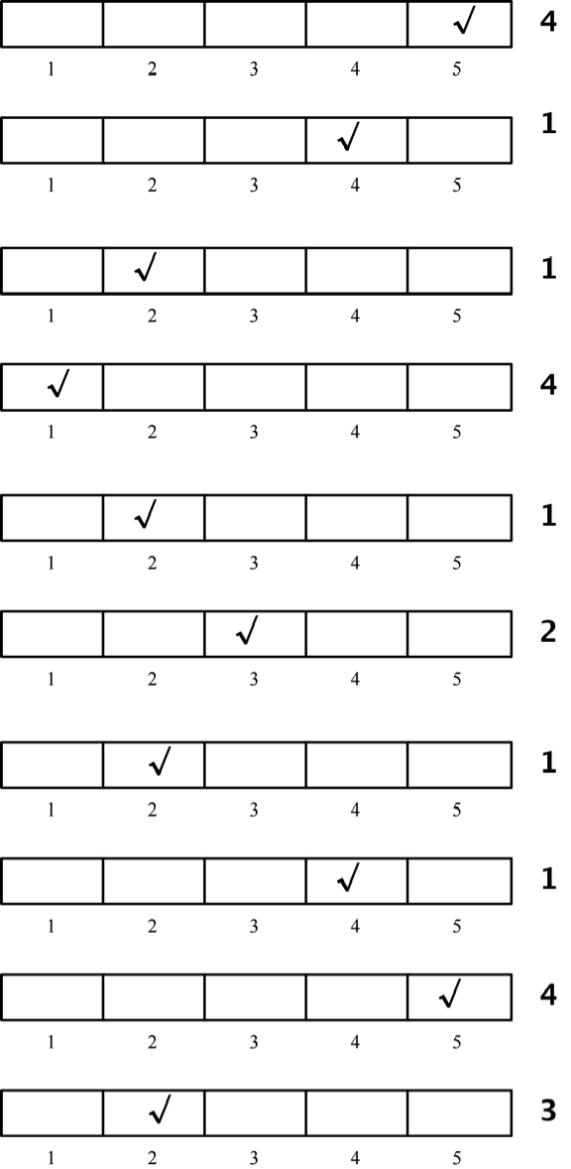

1. I think that I would like to

use this system frequently

2. I found the system unnecessarily

complex

3. I thought the system was easy

to use

4. I think that I would need the

support of a technical person to

be able to use this system

5. I found the various functions in

this system were well integrated

6. I thought there was too much

inconsistency in this system

7. I would imagine that most people

would learn to use this system

very quickly

8. I found the system very

cumbersome to use

9. I felt very confident using the

system

10. I needed to learn a lot of

things before I could get going

with this system

**Total score = 22**

**SUS Score = 22 *22.5 = 55**

## Conclusion

SUS has proved to be a valuable evaluation tool, being robust and reliable. It correlates well with other subjectives measures of usability (eg., the general usability subscale of the SUMI inventory developed in the MUSiC project (Kirakowski, personal communication)). SUS has been made freely available for use in usability assessment, and has been used for a variety of research projects and industrial evaluations; the only prerequisite for its use is that any published report should acknowledge the source of the measure.

## Acknowledgements

SUS was developed as part of the usability engineering programme in integrated office systems development at Digital Equipment Co Ltd., Reading, United Kingdom.

## References

Bevan, N, Kirakowski, J and Maissel, J, 1991, What is Usability?, in H.-J. Bullinger, (Ed.). *Human Aspects in Computing: Design and use of interactive systems and work with terminals*, Amsterdam: Elsevier.

Kirakowski, J and Corbett, M, 1988, Measuring User Satisfaction, in D M Jones and R Winder (Eds.) *People and Computers IV*. Cambridge: Cambridge University Press.

Pratchett, T., 1990 *Moving Pictures*. London: Gollancz